**DAILY ONLINE ACTIVITIES SUMMARY**

|  |  |  |  |  |  |  |  |  |
| --- | --- | --- | --- | --- | --- | --- | --- | --- |
| **Date:** | **21-05-2020** | | | | | **Name:** | **Latika Kavoor** | |
| **Sem & Sec** | **4th Sem & A-Section** | | | | | **USN:** | **4AL18CS035** | |
| **Online Test Summary** | | | | | | | | |
| **Subject** | | **MES** | | | | | | |
| **Max. Marks** | | **30** | | **Score** | | | **13** | |
| **Certification Course Summary** | | | | | | | | |
| **Course** | **Introduction to Cyber Security** | | | | | | | |
| **Certificate Provider** | | | **ICT Academy - CISCO** | | **Duration** | | | **30 hrs** |
| **Coding Challenges** | | | | | | | | |
| **Problem Statement:** Hint: Create the SLL, and then Reverse the Link in SLL until Head becomes NULL. Each Time Reversing the Link, Head must be moved to next immediate node.  **2** Write a C program to construct a singly linked list by removing duplicate elements in the sorted linked list Description: Take a sorted list and traverse the list. Compare the current node element with next adjacent node. If it is same then delete second element, if not retain. Finally print the resulting list. Sample output: Given list {1,2,2,3,3,3,4} Resulting list{1,2,3,4} | | | | | | | | |
| **Status:Completed** | | | | | | | | |
| **Uploaded the report in Github** | | | | | **Yes** | | | |
| **If yes Repository name** | | | | | <https://github.com/Latika31/lockdown-coding> | | | |
| **Uploaded the report in slack** | | | | | **Yes** | | | |

Online Test Details: (Attach the snapshot and briefly write the report for the same)

Took Mes test from 10:00am to 10:40am

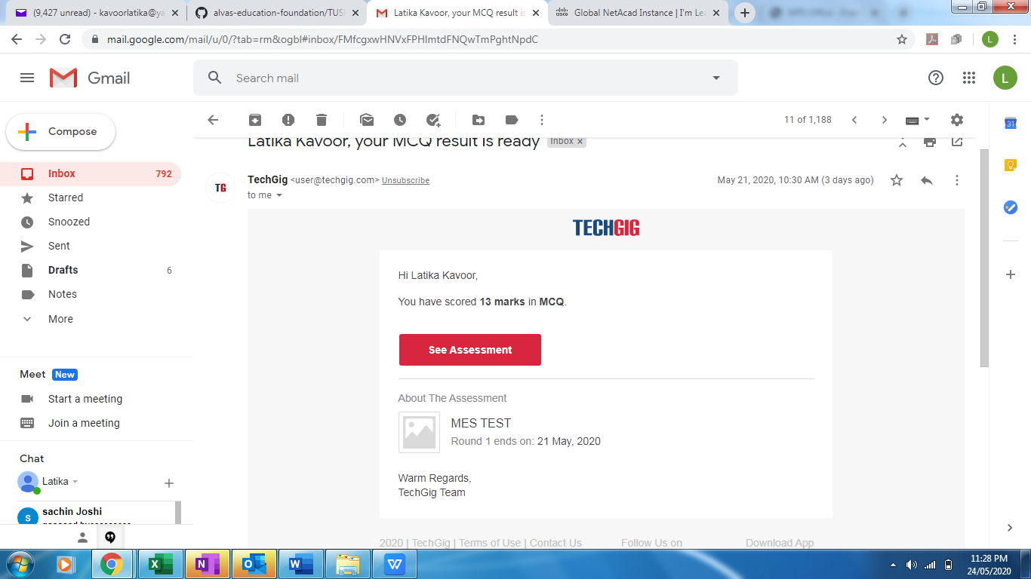

Certification Course Details: (Attach the snapshot and briefly write the report for the same)

Continued with the modules of introduction to cyber security

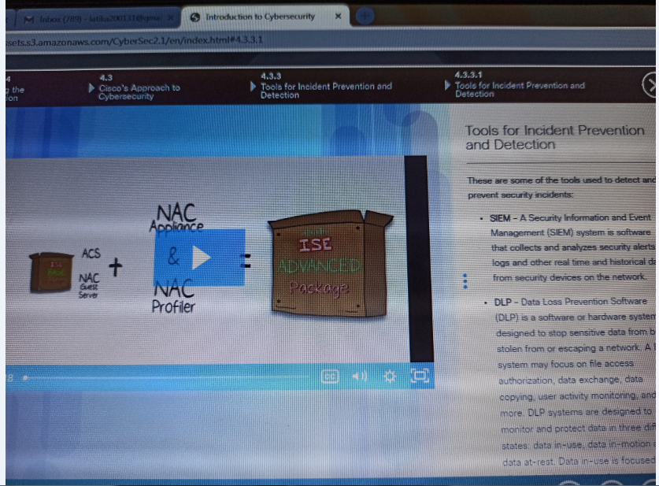

Coding Challenges Details: (Attach the snapshot and briefly write the report for the same)

Solved problems and uploaded on github

